**Title of PBL:**

**Project based report of design and analysis of multi-story building**

**Bajrang Sikarwar, Rohit Dandotiya, Sanju Prajapati**

**Introduction**

The design and analysis of multistorey buildings is a crucial aspect of modern architecture and civil engineering. This project focuses on understanding the principles behind the structural design, load analysis, and safety considerations for multistorey buildings.

**2. Objectives**

* To design a multistorey building considering structural integrity and aesthetic appeal.
* To analyze the load-bearing capacity and stability of the structure.
* To understand and apply building codes and regulations.

**3. Methodology**

* **Literature Review:** Reviewed relevant literature on structural design and analysis techniques.
* **Software Utilization:** Used structural design software (e.g., AutoCAD, SAP2000) for modeling and analysis.
* **Site Visits:** Conducted visits to existing multistorey buildings for practical insights.

**4. Design Considerations**

**4.1 Site Selection**

* Location: Urban area with high population density.
* Accessibility: Proximity to public transport and essential services.

**4.2 Structural Design**

* **Materials:** Selection of concrete and steel for durability and strength.
* **Design Standards:** Adherence to local building codes (e.g., IS codes).

**4.3 Architectural Features**

* Floor plans, elevations, and sections were created to represent the building’s layout and aesthetics.

**5. Analysis**

**5.1 Load Analysis**

* **Dead Loads:** Weight of the structural elements.
* **Live Loads:** Anticipated occupancy loads.
* **Wind Loads:** Consideration of local wind speed and direction.
* **Seismic Analysis:** Assessment based on the seismic zone of the site.

**5.2 Structural Modeling**

Using software, we modeled the building to assess:

* Bending moments
* Shear forces
* Deflections

Images of Analysis of multistory Building model

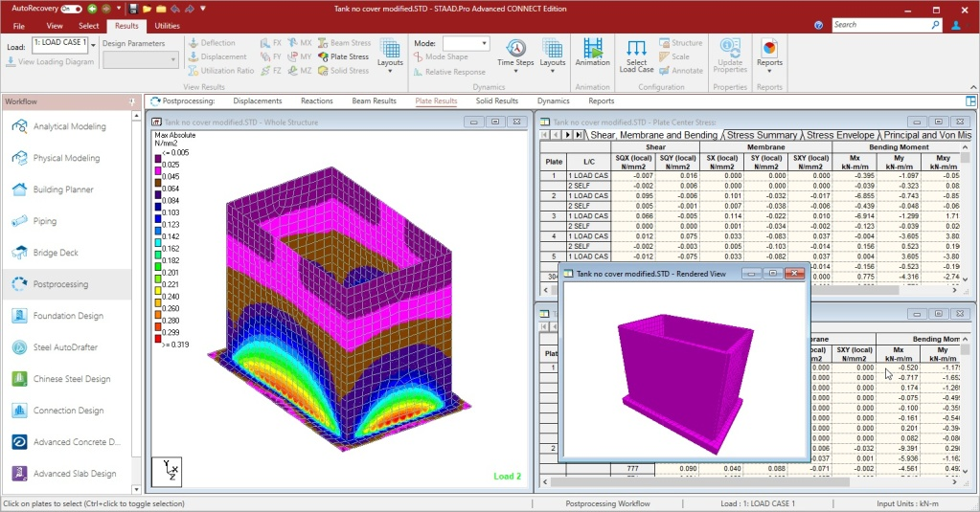



**6. Results**

**6.1 Structural Integrity**

* The building design can safely support the intended loads with a suitable factor of safety.
* Key findings from the analysis indicated adequate performance under static and dynamic loads.

**6.2 Cost Estimation**

* Preliminary cost analysis indicated a feasible budget aligning with local construction costs.

**7. Conclusion**

The project successfully demonstrated the design and analysis process of a multistorey building. Through collaborative efforts, we gained practical insights into structural engineering and project management. Future work could explore more advanced topics such as sustainability and smart building technologies.

**8. References**

1. IS 456:2000 - Code of Practice for Plain and Reinforced Concrete.
2. IS 1893:2016 - Criteria for Earthquake Resistant Design of Structures.
3. Structural Analysis Software Documentation (e.g., SAP2000 User Manual).
4. Relevant journal articles on building design and structural engineering.